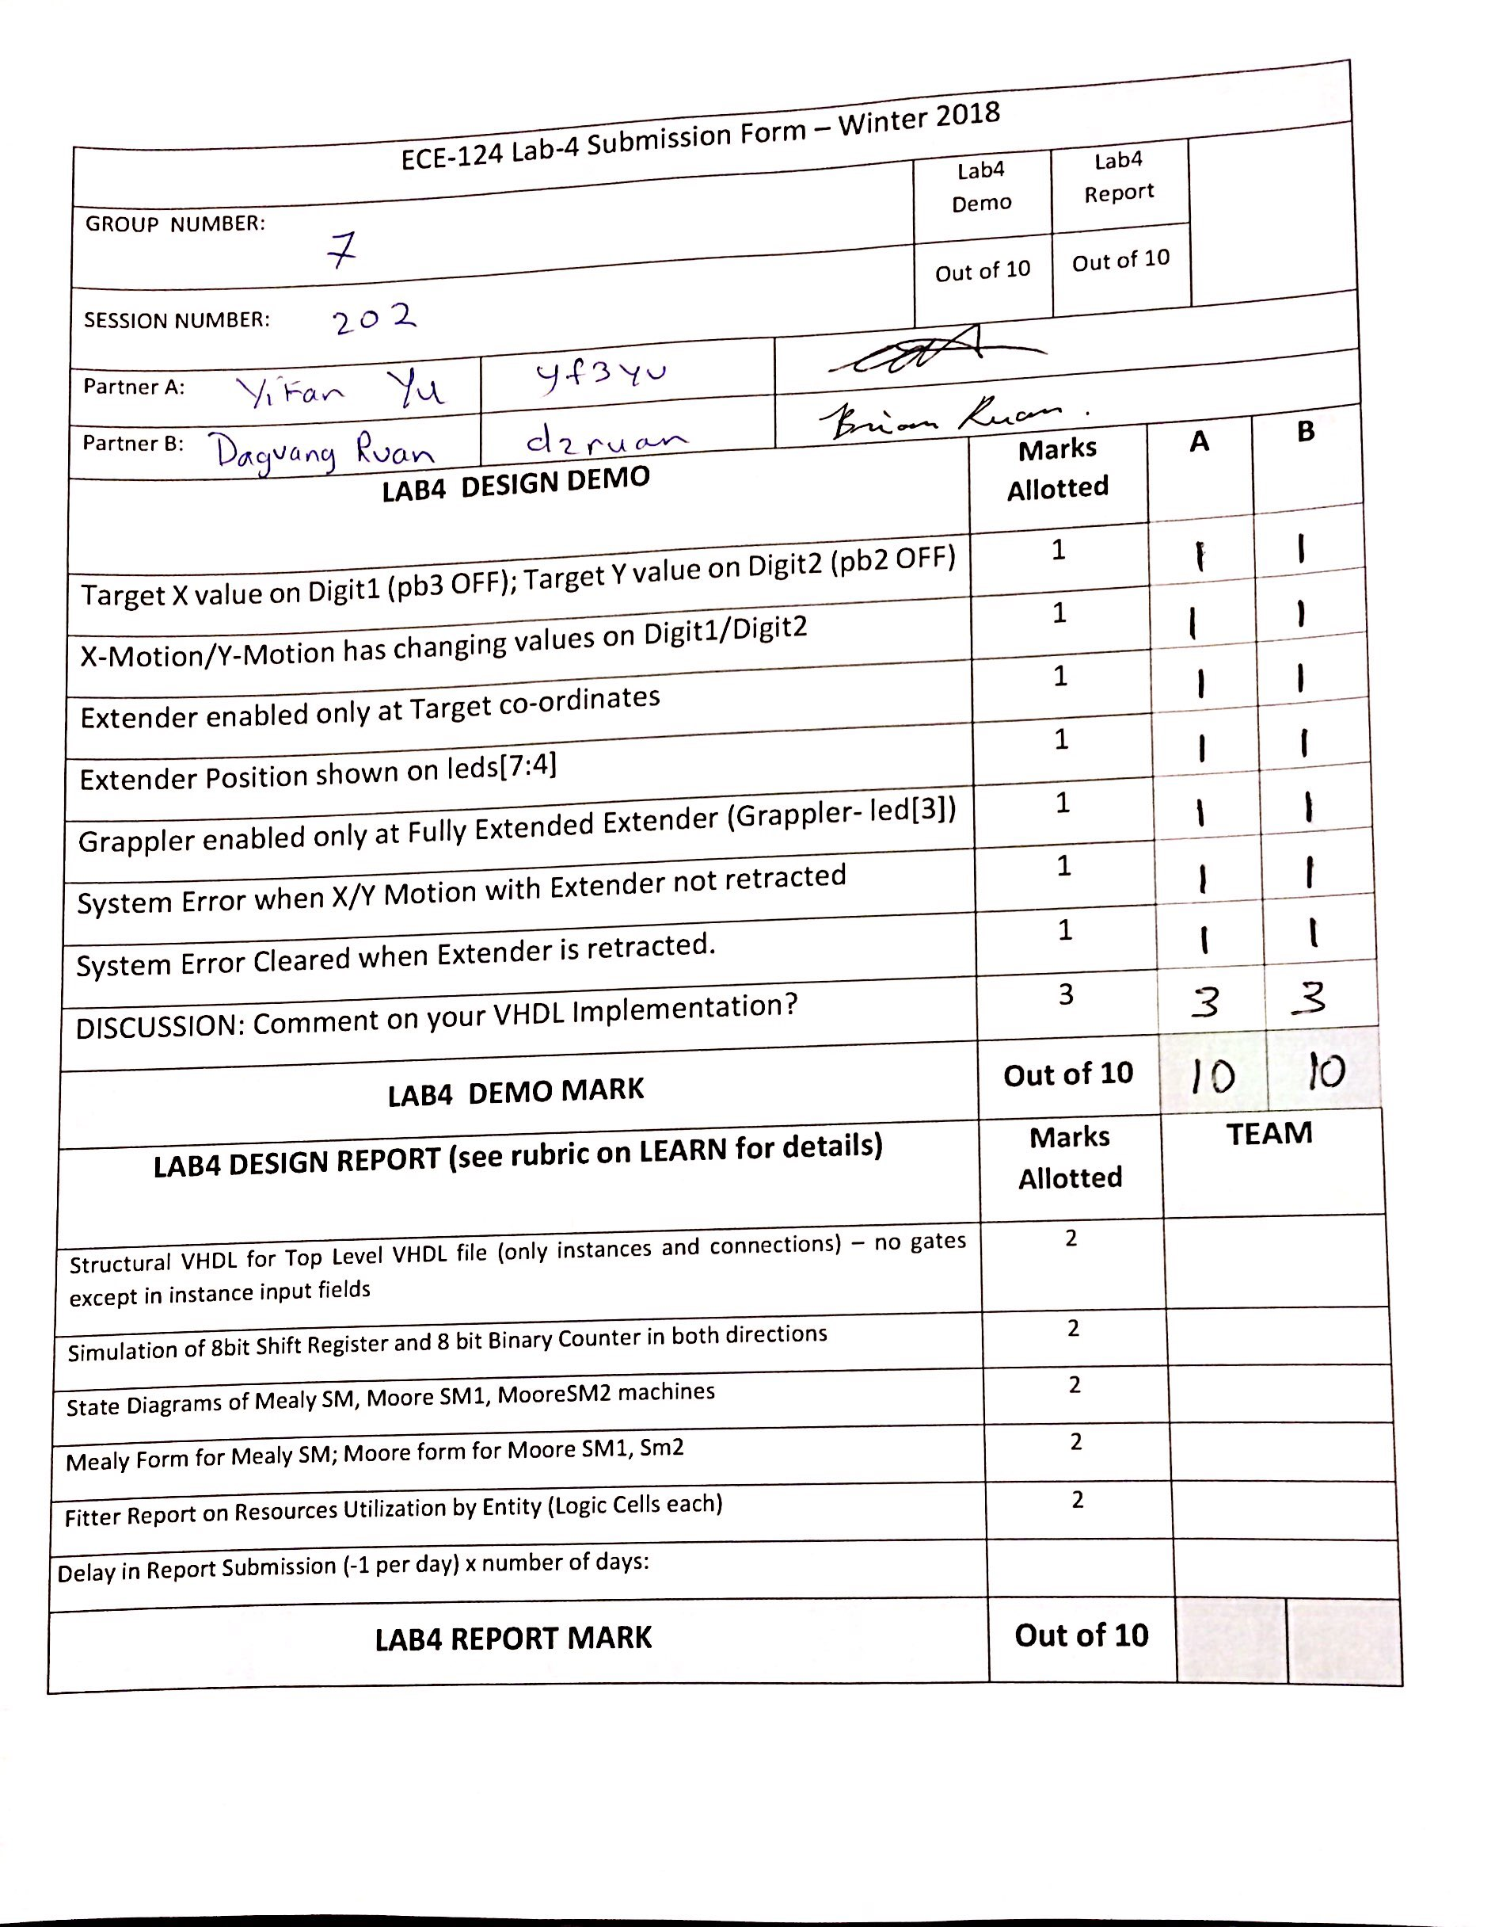

# LAB4 GRP7 SESS202 REPORT

## VHDL SOURCE CODE 1: TOP LEVEL STRUCTURAL

LIBRARY ieee;

USE ieee.std_logic_1164.ALL;

USE ieee.numeric_std.ALL;

ENTITY LogicalStep_Lab4_top IS

PORT

(

clkin_50 : in std_logic;

rst_n : in std_logic;

pb : in std_logic_vector(3 downto 0);

sw : in std_logic_vector(7 downto 0); -- The switch inputs

leds : out std_logic_vector(7 downto 0); -- for displaying the switch content

seg7_data : out std_logic_vector(6 downto 0); -- 7-bit outputs to a 7-segment

seg7_char1 : out std_logic; -- seg7 digi selectors

seg7_char2 : out std_logic -- seg7 digi selectors

);

END LogicalStep_Lab4_top;

ARCHITECTURE SimpleCircuit OF LogicalStep_Lab4_top IS

COMPONENT SevenSegment is port (

hex : in std_logic_vector(3 downto 0); -- The 4 bit data to be displayed

sevenseg : out std_logic_vector(6 downto 0) -- 7-bit outputs to a 7-segment

);

end COMPONENT;

COMPONENT segment7_mux is

port (

clk : in std_logic := '0';

DIN2 : in std_logic_vector(6 downto 0);

DIN1 : in std_logic_vector(6 downto 0);

DOUT : out std_logic_vector(6 downto 0);

DIG2 : out std_logic;

DIG1 : out std_logic

);

end COMPONENT;

COMPONENT MealyStatemachine IS

Port(

clk_input, resetButton : IN std_logic;

X_EQ, X_GT, X_LT : IN std_logic; --comparing DESIRED TO ACTUAL

Y_EQ, Y_GT, Y_LT : IN std_logic; --comparing DESIRED TO ACTUAL

extenderOut : IN std_logic;

X_MOTION, Y_MOTION : IN std_logic;

X_Clk_en, X_UPorDOWN: OUT std_logic;

Y_Clk_en, Y_UPorDOWN: OUT std_logic;

ExtenderEnable: OUT std_logic;

isError : OUT std_logic

);

END COMPONENT;

COMPONENT Bin_Counter4bit is port

(

Main_clk : in std_logic;

rst_n : in std_logic := '0';

clk_en : in std_logic := '0';

up1_down0 : in std_logic := '0';

counter_bits : out std_logic_vector(3 downto 0)

);

end COMPONENT;

COMPONENT FourBitComparator is port (

bitA0, bitA1, bitA2, bitA3, bitB0, bitB1, bitB2, bitB3 : in std_logic;

AGTB : out std_logic;

AEQB : out std_logic;

ALTB : out std_logic

);

end COMPONENT;

COMPONENT Grappler IS Port (

clk_input, rst_n, controlButton, enable : IN std_logic;

grappleControl : OUT std_logic

);

end COMPONENT;

COMPONENT Bidir_shift_reg is port

(

CLK : in std_logic :='0';

RESET_n : in std_logic :='0';

CLK_EN : in std_logic :='0';

LEFT0_RIGHT1 : in std_logic :='0';

REG_BITS : OUT std_logic_vector(3 downto 0)

);

end COMPONENT;

COMPONENT Extender IS Port

(

clk_input, rst_n, controlButton, enable : IN std_logic;

currentShiftValue : IN std_logic_vector(3 downto 0);

bitShifting, extenderOut, bitShiftDirection, grapplerEnable : OUT std_logic

);

END COMPONENT;

COMPONENT mux is port (

hex_in1, hex_in2 : in std_logic_vector(6 downto 0);

mux_select :in std_logic;

hex_out : out std_logic_vector(6 downto 0)

);

end COMPONENT;

COMPONENT muxSingle is port (

hex_in1, hex_in2 : in std_logic;

mux_select :in std_logic;

hex_out : out std_logic

);

end COMPONENT;

COMPONENT FlashCounter is port

(

Main_clk : in std_logic;

rst_n : in std_logic := '0';

clk_en : in std_logic := '0';

up1_down0 : in std_logic := '0';

counter_bits : out std_logic

);

end COMPONENT;

----------------------------------------------------------------------------------------------------

CONSTANT SIM : boolean := FALSE; -- set to TRUE for simulation runs otherwise keep at 0.

CONSTANT CLK_DIV_SIZE : INTEGER := 26; -- size of vectors for the counters

SIGNAL Main_Clk : STD_LOGIC; -- main clock to drive sequencing of State Machine

SIGNAL bin_counter : UNSIGNED(CLK_DIV_SIZE-1 downto 0); -- := to_unsigned(0,CLK_DIV_SIZE); -- reset binary counter to zero

----------------------------------------------------------------------------------------------------

SIGNAL XTARGET7seg, YTARGET7seg : std_logic_vector(6 downto 0);

SIGNAL XCURRENT, YCURRENT : std_logic_vector(3 downto 0);

SIGNAL XCURRENT7seg, YCURRENT7seg : std_logic_vector(6 downto 0);

SIGNAL XMUX7seg, YMUX7seg: std_logic_vector(6 downto 0);

SIGNAL XTargLTCurr, XTargEQCurr, XTargGTCurr : std_logic;

SIGNAL YTargLTCurr, YTargEQCurr, YTargGTCurr : std_logic;

SIGNAL bitShiftDirControl, bitShiftEnable : std_logic;

SIGNAL currentShiftValue : std_logic_vector(3 downto 0);

SIGNAL extenderOutSignal : std_logic;

SIGNAL X_ClockEnable, Y_ClockEnable : std_logic;

SIGNAL X_Direction, Y_Direction : std_logic;

SIGNAL GrappleEnableSignal : std_logic;

SIGNAL extenderEnableSignal : std_logic;

SIGNAL ERROR7seg, NOTHING7seg, ERROR7segOutput : std_logic_vector(6 downto 0);

SIGNAL X_ERROR_AND_VALUE7seg, Y_ERROR_AND_VALUE7seg:std_logic_vector(6 downto 0);

SIGNAL ERROR : std_logic;

SIGNAL MUX_CLOCK : std_logic;

SIGNAL FLASH: std_logic;

----------------------------------------------------------------------------------------------------

BEGIN

-- CLOCKING GENERATOR WHICH DIVIDES THE INPUT CLOCK DOWN TO A LOWER FREQUENCY

BinCLK: PROCESS(clkin_50, rst_n) is

BEGIN

IF (rising_edge(clkin_50)) THEN -- binary counter increments on rising clock edge

bin_counter <= bin_counter + 1;

END IF;

END PROCESS;

Clock_Source:

Main_Clk <=

clkin_50 when sim = TRUE else -- for simulations only

std_logic(bin_counter(23)); -- for real FPGA operation

---------------------------------------------------------------------------------------------------

leds (7 downto 4) <= currentShiftValue (3 downto 0);

leds (0) <= ERROR;

ERROR7seg <= "1111001";

NOTHING7seg <= "0000000";

---------------------------------------------------------------------------------------------------

INST1XTARGET: SevenSegment PORT MAP (sw(7 downto 4),XTARGET7Seg);

INST2YTARGET: SevenSegment PORT MAP (sw(3 downto 0),YTARGET7Seg);

INST11XCURRENT: SevenSegment PORT MAP (XCURRENT,XCURRENT7seg);

INST12YCURRENT: SevenSegment PORT MAP (YCURRENT,YCURRENT7seg);

INST13MUX_X:mux PORT MAP (

XCURRENT7seg, XTARGET7Seg,

pb(3),

XMUX7seg);

INST14MUX_Y:mux PORT MAP (

YCURRENT7seg, YTARGET7Seg,

pb(2),

YMUX7seg);

INST15X_MUX_ERROR :mux PORT MAP (

XMUX7seg, ERROR7segOutput,

ERROR,

X_ERROR_AND_VALUE7seg);

INST16Y_MUX_ERROR :mux PORT MAP (

YMUX7seg,ERROR7segOutput,

ERROR,

Y_ERROR_AND_VALUE7seg);

INST18ERROR_AND_NOTHING: mux PORT MAP(

ERROR7seg, NOTHING7seg,

FLASH,

ERROR7segOutput);

INST19FLASH: FlashCounter PORT MAP

(

std_logic(bin_counter(23)),

rst_n,

'1',

'1',

FLASH

);

INST3: segment7_mux PORT MAP (clkin_50, X_ERROR_AND_VALUE7seg(6 downto 0), Y_ERROR_AND_VALUE7seg(6 downto 0), seg7_data(6 downto 0), seg7_char1, seg7_char2);

INST4X: Bin_Counter4bit PORT MAP (Main_Clk,rst_n,X_ClockEnable,X_Direction,XCURRENT(3 downto 0) );

INST5Y: Bin_Counter4bit PORT MAP (Main_Clk,rst_n, Y_ClockEnable,Y_Direction,YCURRENT(3 downto 0) );

INST6X: FourBitComparator PORT MAP (

sw(4),sw(5), sw(6), sw(7),

XCURRENT(0), XCURRENT(1), XCURRENT(2), XCURRENT(3),

XTargGTCurr, XTargEQCurr, XTargLTCurr);

INST7Y: FourBitComparator PORT MAP (

sw(0),sw(1), sw(2), sw(3),

YCURRENT(0), YCURRENT(1), YCURRENT(2), YCURRENT(3),

YTargGTCurr, YTargEQCurr, YTargLTCurr);

INST8GrapplerSM: Grappler PORT MAP (Main_Clk, rst_n, pb(0) , GrappleEnableSignal, leds(3));

INST9: Bidir_shift_reg PORT MAP(

Main_Clk, rst_n,

bitShiftEnable, bitShiftDirControl,

currentShiftValue (3 downto 0) );

--

INST10: Extender PORT MAP (

Main_Clk, rst_n, pb(1), extenderEnableSignal,

currentShiftValue(3 downto 0),

bitShiftEnable, extenderOutSignal, bitShiftDirControl,GrappleEnableSignal

);

INSTMEALY: MealyStatemachine PORT MAP (

Main_Clk, rst_n,

XTargEQCurr, XTargGTCurr, XTargLTCurr,

YTargEQCurr, YTargGTCurr, YTargLTCurr,

extenderOutSignal,

pb(3), pb(2),

X_ClockEnable, X_Direction,

Y_ClockEnable, Y_Direction,

extenderEnableSignal,

ERROR

);

--INST13ERROR_MUX: mux PORT MAP (ERROR7seg,

END SimpleCircuit;

## Simulation 1: 8-Bits Shift Register

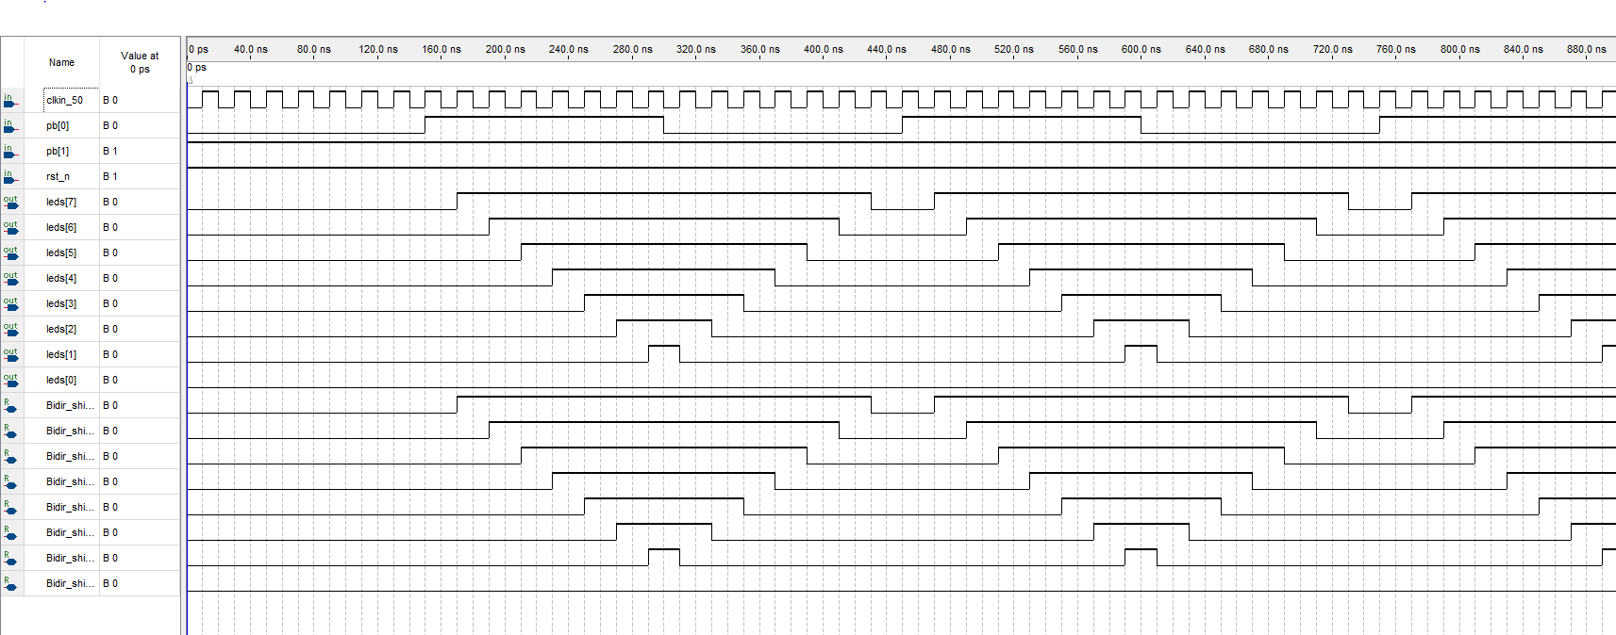

## Simulation 2: 8-Bits Counter

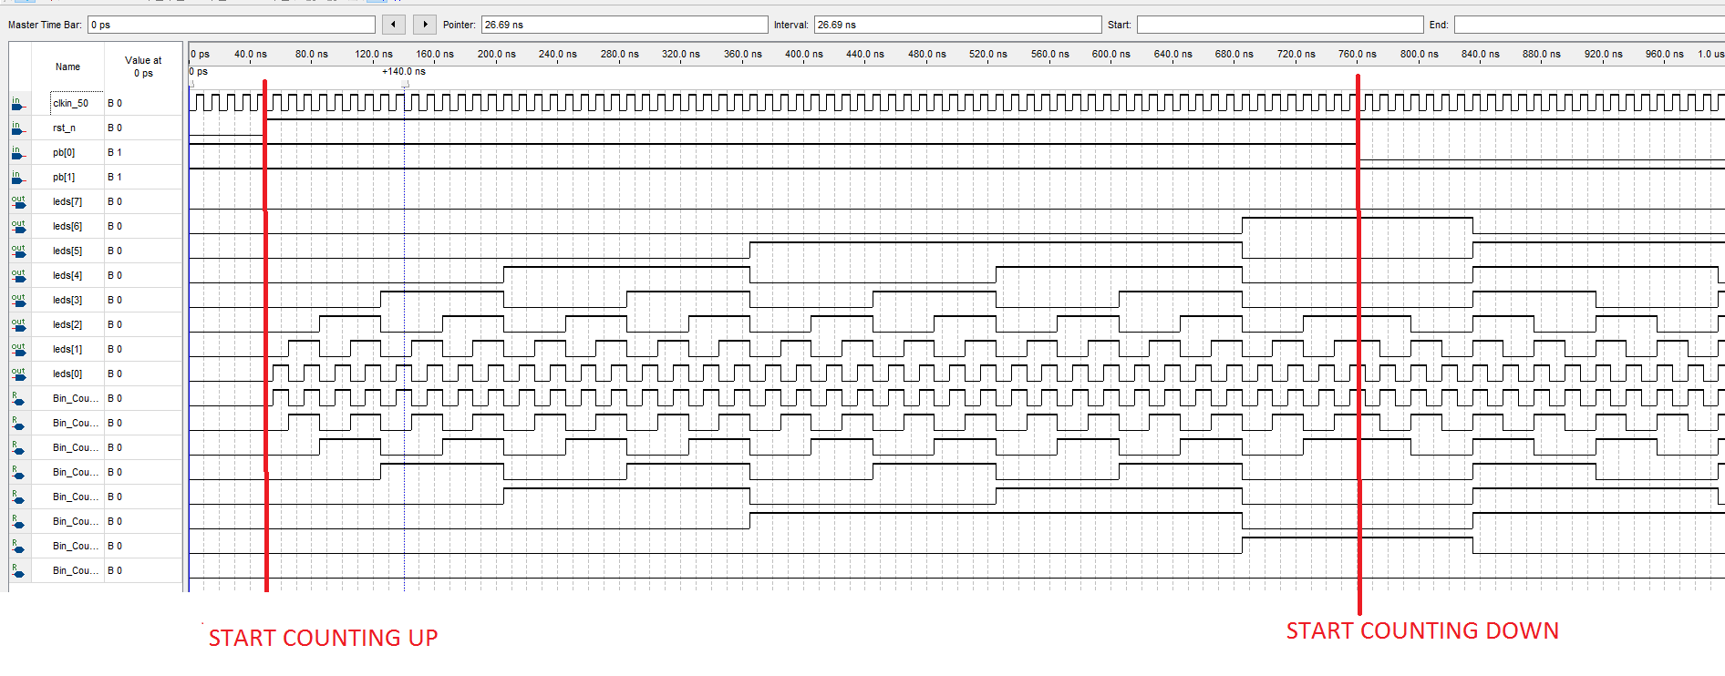

## State Diagram 1 Mealy State Machine

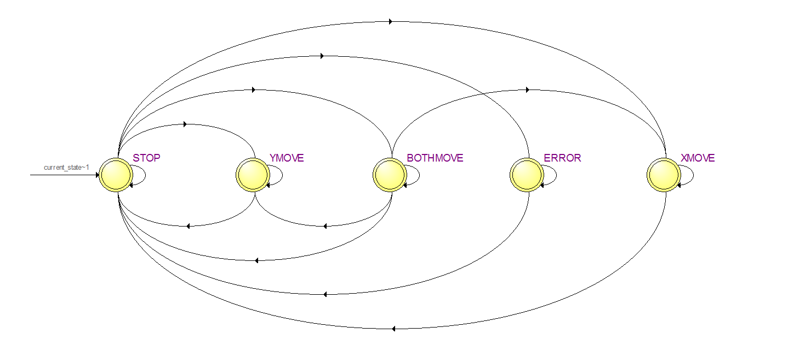

## State Diagram 2: Extender Moore State Machine

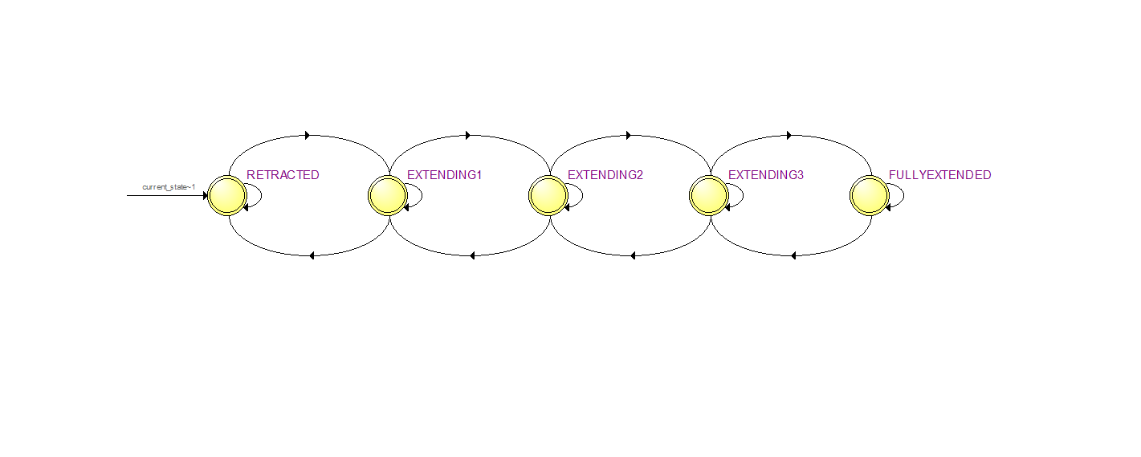

## State Diagram 3: Grappler Moore State Machine

## Form of the SM

### STATE MACHINE 1: MEALY

] library ieee;

use ieee.std_logic_1164.all;

use ieee.numeric_std.all;

Entity MealyStatemachine IS Port

(

clk_input, resetButton : IN std_logic;

X_EQ, X_GT, X_LT : IN std_logic; --comparing DESIRED TO ACTUAL

Y_EQ, Y_GT, Y_LT : IN std_logic; --comparing DESIRED TO ACTUAL

extenderOut : IN std_logic;

X_MOTION, Y_MOTION : IN std_logic;

X_Clk_en, X_UPorDOWN: OUT std_logic;

Y_Clk_en, Y_UPorDOWN: OUT std_logic;

ExtenderEnable: OUT std_logic;

isError : OUT std_logic := '0'-- need to put that somewhere

);

END ENTITY;

Architecture behaviour of MealyStatemachine is

-- state for the X control and Y control

TYPE STATE IS (XMOVE, STOP, YMOVE, BOTHMOVE, ERROR);

SIGNAL current_state, next_state : STATE; -- our signal for currentState and nextSate

BEGIN

--------------------------------------------------------------------------------

--State Machine:

--------------------------------------------------------------------------------

-----------------------------CONTROL FOR X-------------------------------------

-- REGISTER_LOGIC PROCESS:

Register_Section: PROCESS (clk_input, resetButton, next_state) -- this process synchronizes the activity to a clock

BEGIN

IF (resetButton = '0') THEN

current_state <= STOP;

ELSIF(rising_edge(clk_input)) THEN

current_state <= next_State;

END IF;

END PROCESS;

-- TRANSITION LOGIC PROCESS

Transition_Section: PROCESS (current_state, X_EQ, X_GT, X_LT,Y_EQ, Y_GT, Y_LT,extenderOut,X_MOTION, Y_MOTION)

BEGIN

CASE current_state IS

--switching states depending on the value of the comparaison

WHEN STOP =>

IF( X_EQ = '0' AND Y_EQ = '0' AND (X_MOTION='0') AND (Y_MOTION='0') and extenderout = '0') THEN

-- both are bigger or smaller AND we ve got both buttons at active low

next_state <= BOTHMOVE;

ELSIF((X_GT='1' or X_LT='1') AND (X_MOTION='0') and extenderout = '0' ) THEN

next_state <= XMOVE;

ELSIF((Y_GT='1' or Y_LT='1') AND (Y_MOTION='0') and extenderout = '0' ) THEN

next_state <= YMOVE;

ELSIF( (X_EQ = '0' or Y_EQ = '0') and ((X_MOTION='0') or (Y_MOTION='0')) and extenderOut = '1') THEN

next_state <= ERROR;

ELSE

next_state <= STOP;

END IF;

WHEN XMOVE =>

IF( X_EQ = '1') THEN

next_state <= STOP;

ELSE

next_state <= XMOVE;

END IF;

WHEN YMOVE =>

IF( Y_EQ = '1') THEN

next_state <= STOP;

ELSE

next_state <= YMOVE;

END IF;

WHEN BOTHMOVE =>

IF(Y_EQ = '1' and X_EQ = '1') THEN

next_state <= STOP;

ELSIF( Y_EQ = '1' and X_EQ = '0') THEN

next_state <= XMOVE;

ELSIF( Y_EQ = '0' and X_EQ = '1')THEN

next_state <= YMOVE;

ELSE

next_state <= BOTHMOVE;

END IF;

WHEN ERROR =>

IF( extenderOut = '0') THEN

next_state <= STOP;

ELSE

next_state <= ERROR;

END IF;

WHEN OTHERS =>

next_state <= STOP;

END CASE;

END PROCESS;

-- DECODER SECTION PROCESS

Decoder_Section: PROCESS (current_state, X_EQ, X_GT, X_LT,Y_EQ, Y_GT, Y_LT,extenderOut,X_MOTION, Y_MOTION)

BEGIN

CASE current_state IS

WHEN STOP =>

X_CLK_en <= '0';

Y_CLK_en <= '0';

isError <= '0';

IF (X_EQ='1'AND Y_EQ='1') THEN

ExtenderEnable <= '1';

ELSE

ExtenderEnable <= '0';

END IF;

WHEN XMOVE =>

IF (X_GT='1') THEN

X_CLK_en <= '1';

X_UPorDOWN <= '1';

ELSIF (X_LT = '1') THEN

-- count forward

X_CLK_en <= '1';

X_UPorDOWN <= '0';

ELSE

X_CLK_en <= '0';

END IF;

WHEN YMOVE =>

Y_CLK_en <= '0';

IF (Y_GT='1') THEN

-- count backward

Y_CLK_en <= '1';

Y_UPorDOWN <= '1';

ELSIF (Y_LT = '1') THEN

-- count forward

Y_CLK_en <= '1';

Y_UPorDOWN <= '0';

ELSE

Y_CLK_en <= '0';

END IF;

WHEN BOTHMOVE =>

IF (X_GT='1') THEN

X_CLK_en <= '1';

X_UPorDOWN <= '1';

ELSIF (X_LT = '1') THEN

-- count forward

X_CLK_en <= '1';

X_UPorDOWN <= '0';

ELSE

X_CLK_en <= '0';

END IF;

IF (Y_GT='1') THEN

-- count backward

Y_CLK_en <= '1';

Y_UPorDOWN <= '1';

ELSIF (Y_LT = '1') THEN

-- count forward

Y_CLK_en <= '1';

Y_UPorDOWN <= '0';

ELSE

Y_CLK_en <= '0';

END IF;

WHEN ERROR =>

--IF ( (Y_EQ = '0' OR X_EQ = '0') AND (X_MOTION = '0' OR Y_MOTION = '0') )THEN

isError <= '1';

X_CLK_en <= '0';

Y_CLK_en <= '0';

ExtenderEnable <= '1';

--ELSE

--isError <= '0';

--END IF;

END CASE;

END PROCESS;

END ARCHITECTURE behaviour;

### STATE MACHINE 2: EXTENDER MOORE

library ieee;

use ieee.std_logic_1164.all;

use ieee.numeric_std.all;

Entity Extender IS Port

(

clk_input, rst_n, controlButton, enable : IN std_logic;

currentShiftValue : IN std_logic_vector(3 downto 0);

bitShifting, extenderOut, bitShiftDirection, grapplerEnable : OUT std_logic

);

END ENTITY;

Architecture SM of Extender is

TYPE STATE_NAMES IS (RETRACTED,EXTENDING1, EXTENDING2, EXTENDING3, FULLYEXTENDED); -- list all the STATE_NAMES values

SIGNAL current_state, next_state : STATE_NAMES; -- signals of type STATE_NAMES

BEGIN

--------------------------------------------------------------------------------

--State Machine:

--------------------------------------------------------------------------------

-- REGISTER_LOGIC PROCESS:

Register_Section: PROCESS (clk_input, rst_n, next_state) -- this process synchronizes the activity to a clock

BEGIN

IF (rst_n = '0') THEN

current_state <= RETRACTED;

ELSIF(rising_edge(clk_input)) THEN

current_state <= next_State;

END IF;

END PROCESS;

-- TRANSITION LOGIC PROCESS

Transition_Section: PROCESS ( current_state,controlButton, enable, currentShiftValue)

BEGIN

CASE current_state IS

WHEN RETRACTED =>

IF(controlButton = '0' AND enable = '1') THEN

next_state <= EXTENDING1;

ELSE

next_state <= RETRACTED;

END IF;

WHEN EXTENDING1 =>

IF(currentShiftValue = "0000") THEN

next_state <= EXTENDING2;

ELSIF(currentShiftValue = "1000") THEN

next_state <= RETRACTED;

ELSE

next_state <= EXTENDING1;

END IF;

WHEN EXTENDING2 => --forward stays here twice

IF(currentShiftValue = "1000") THEN

next_state <= EXTENDING3;

ELSIF(currentShiftValue = "1110") THEN

next_state <= EXTENDING1;

ELSE

next_state <= EXTENDING2;

END IF;

WHEN EXTENDING3 =>

IF(currentShiftValue = "1110") THEN

next_state <= FULLYEXTENDED;

ELSIF(currentShiftValue = "1111") THEN

next_state <= EXTENDING2;

ELSE

next_state <= EXTENDING3;

END IF;

WHEN FULLYEXTENDED =>

IF(controlButton = '0' AND enable = '1' ) THEN

next_state <= EXTENDING3;

ELSE

next_state <= FULLYEXTENDED;

END IF;

WHEN OTHERS =>

next_state <= RETRACTED;

END CASE;

END PROCESS;

-- DECODER SECTION PROCESS

Decoder_Section: PROCESS ( current_state,controlButton, enable, currentShiftValue)

BEGIN

CASE current_state IS

WHEN RETRACTED =>

bitShifting <= '0';

extenderOut<= '0';

grapplerEnable <= '0';

bitShiftDirection <= '1';

WHEN EXTENDING1 =>

bitShifting <= '1';

extenderOut<= '1';

grapplerEnable <= '0';

WHEN EXTENDING2 =>

bitShifting <='1';

extenderOut<= '1';

grapplerEnable <= '0';

WHEN EXTENDING3 =>

bitShifting <= '1';

extenderOut<= '1';

grapplerEnable <= '0';

WHEN FULLYEXTENDED =>

bitShifting <= '0';

extenderOut<= '1';

grapplerEnable <= '1';

bitShiftDirection <= '0';

WHEN others =>

bitShifting <= '0';

extenderOut<= '0';

grapplerEnable <= '0';

bitShiftDirection <= '1';

END CASE;

END PROCESS;

END ARCHITECTURE SM;

### STATE MACHINE 3: GRAPPLER MOORE

library ieee;

use ieee.std_logic_1164.all;

use ieee.numeric_std.all;

Entity Grappler IS Port

(

clk_input, rst_n, controlButton, enable : IN std_logic;

grappleControl : OUT std_logic

);

END ENTITY;

Architecture STATEMACHINE of Grappler is

TYPE STATE_NAMES IS (STOP, GRAPPLE); -- list all the STATE_NAMES values

SIGNAL current_state, next_state : STATE_NAMES; -- signals of type STATE_NAMES

BEGIN

--------------------------------------------------------------------------------

--State Machine:

--------------------------------------------------------------------------------

-- REGISTER_LOGIC PROCESS:

Register_Section: PROCESS (clk_input, rst_n, next_state) -- this process synchronizes the activity to a clock

BEGIN

IF (rst_n = '0') THEN

current_state <= STOP;

ELSIF(rising_edge(clk_input)) THEN

current_state <= next_State;

END IF;

END PROCESS;

-- TRANSITION LOGIC PROCESS

Transition_Section: PROCESS (current_state,controlButton, enable)

BEGIN

CASE current_state IS

WHEN STOP =>

IF( controlButton = '0' AND enable= '1' ) THEN --pressed

next_state <= GRAPPLE;

ELSE

next_state <= STOP;

END IF;

WHEN GRAPPLE =>

IF( controlButton = '0' OR enable= '0') THEN --pressed

next_state <= STOP;

ELSE

next_state <= GRAPPLE;

END IF;

WHEN OTHERS =>

next_state <= STOP;

END CASE;

END PROCESS;

-- DECODER SECTION PROCESS

Decoder_Section: PROCESS (current_state,controlButton, enable)

BEGIN

CASE current_state IS

WHEN STOP =>

grappleControl <= '0';

WHEN GRAPPLE =>

grappleControl <= '1';

WHEN others =>

grappleControl <= '0';

END CASE;

END PROCESS;

END ARCHITECTURE STATEMACHINE;

### Difference between a Mealy and a Moore

The output of a Mealy machine is dependent on both the input and the current state while the output of a Moore machine is only dependent on the current state.

## Fitter Report on Resources Utilization by Entity

